Kuumba C++ Core

Lightweight C++ Component Model
Ted V. Kremer – August 18, 2005

The following design defines a lightweight component model for specifying component types and their implementation as encapsulated and dynamically loaded units of deployment.

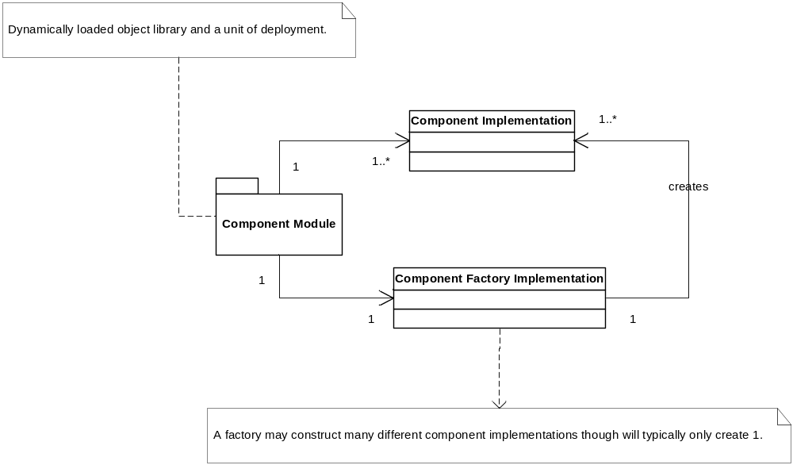

Each module contains 1 and only 1 factory and at least 1 component implementation. All services of a component are defined by the component’s type. A component’s factory may create instances of different components with additional methods on its factory type or more commonly the component created by the factory will create and manage additional components in an object hierarchy. This approach to component development favors aggregation over implementation inheritance.

Designing and writing software using this component model encourages thinking in terms of component specifications and providers. Whereby a component specification, its published services, is represented by a component type and different providers, each encapsulated into its own component module and implementation, are created that conform to the specification. This allows runtime behavior to be changed by simply making the component module name an application parameter. This encourages very loose coupling and strongly encapsulated abstractions when designing software parts; a fundamental tenet in component design.

Design
A component is a dynamic, binary, and stand-alone module with a single exported entry point, k_constructFactory, returning a factory instance from which a component instance is constructed. Components are always public interface based and the interface is all that is exposed from the component. All implementation details are encapsulated in private classes within the component implementation.

AccountingLedgerFactory
k_constructFactory()
j_accounting_ledger.dll/so
AccountingDebitLedger
AccountingCreditLedger
ILedger
IComponent
IComponentFactory
ILedgerFactory

Components are dynamically loaded and may be reloaded during program execution. Components are always in-process and heap-created. Thus no additional infrastructure is required as is for beefier component models that simultaneously support local and remote calling (e.g. parameter marshalling). However this approach requires strict ownership policies to ensure proper clean-up of component resources. Use of an automatic pointer object is recommended for automatic clean-up of component instances or ref-counted automatic pointers for mutual dependency.

Components are identified by a lower-case name of the form: x_package_component#version; where ‘x’ is a vendor designation, ‘package’ is an optional logical package or subsystem of the component and ‘component’ is the component name. Versions are identified by appending a “#” symbol to the end of the component name followed by a whole number representing the version. The initial version of a component may exclude the version which is the default version “0”.

Component factory interface specialization is optional as all component factories must provide an implementation that has an empty parameter component constructor. Factories can be specialized to provide construction with arguments (also achieved with an init method on the component) or to change object management behavior (e.g. singleton component).

A utility macro is provided, KCC_COMPONENT_FACTORY_IMPL(<ComponentImplClass>), that will instantiate a parameterized class for a component factory with a default implementation. Should a specialized component factory need be created than the utility macro, KCC_COMPONENT_FACTORY_CUST(<ComponentFactoryImplClass>), is provided to create the exported entry point with an implementation that constructs and returns an instance of the factory implementation class.

**** TODO: describe component metadata ****

Additionally, utility macros to create a component or access a component’s singleton factory by a consumer are provided: KCC_COMPONENT(<ComponentInterface>, <ComponentId>) and KCC_FACTORY(<ComponentFactoryInterface>, <ComponentId>).

Examples of component and component factory consumers and providers follow.

Example: Component Consumer
try
{
kcc::AutoPtr<IMyComponent> s(KCC_COMPONENT(IMyComponent, "x_my_s"));
s->go(IMyComponent::Data("simple test"));

kcc::AutoPtr<IMyComponent> c(KCC_COMPONENT(IMyComponent, "x_my_c"));
c->go(IMyComponent::Data("stock test"));

IMyComponentFactory* f = KCC_FACTORY(IMyComponentFactory, "x_my_f");

kcc::AutoPtr< IMyComponent> f1(f->constructMy());
f1->go(IMyComponent::Data("test"));

kcc::AutoPtr<IMyComponent> f2(f->constructMyEx());
f2->go(IMyComponent::Data("testEx"));
}
catch (kcc::ComponentModule::ComponentNotFound& e)
{
std::cerr << "COMPONENT NOT FOUND: " << e.what() << std::endl;
}
catch (kcc::ComponentModule::FactoryNotFound& e)
{
std::cerr << "FACTORY NOT FOUND: " << e.what() << std::endl;
}

Note the use of macros and ownership responsibilities as consumer must delete component instances in the example.

Example: Component Type
interface IMyComponentFactory : kcc::IComponentFactory
{
virtual IMyComponent* constructMy() = 0; // type-safe version of construct()
virtual IMyComponent* constructMyEx() = 0;
};

NOTE: Specification contains ONLY pure-virtual methods.

interface IMyComponent : kcc::IComponent
{
struct Data
{
Data(const kcc::String& n) : name(n) {}
kcc::String name;
};
virtual void go(const Data& d) = 0;
};

NOTE: Specification contains ONLY pure-virtual methods. Be wary of local data structures like the above as they are part of the interface and may not be altered once deployed. Also, the code for the structure will be copied into each module that includes this file, local structure must be inline, so code bloat may result as well. However, structures such as this are required for many problems so just be aware of the risks.

Example: Component Implementation
struct MySimple : IMyComponent
{
MySimple() { kcc::Log::info3("MySimple ctor"); }
~MySimple () { kcc::Log::info3("MySimple dtor"); }
void go(const Data& d) { kcc::Log::info3("MySimple go: %s", d.name.c_str()); }
};

KCC_COMPONENT_FACTORY_IMPL(kcc::SimpleComponentImpl);

NOTE: Implementation uses stock factory. This would be built into the following binary: k_my_s.dll/so

struct MyFactory : IMyComponentFactory
{
MyFactory() { kcc::Log::info3("MyFactory ctor"); }
~MyFactory() { kcc::Log::info3("MyFactory dtor"); }
kcc::IComponent* construct() { return constructMy(); }
IMyComponent* constructMy() { return new MySimple(); }
IMyComponent* constructMyEx(){ return new MySimpleTwo(); }
};

KCC_COMPONENT_FACTORY_CUST(MyFactory);

**** TODO: ADD METADATA TO EXAMPLE ****

NOTE: Implementation uses custom factory. This would be built into the following binary: k_my_f.dll/so. Additionally, the compoment implementation file will NOT declare KCC_COMPONENT_FACTORY_IMPL as the factory is customized and provided above.

